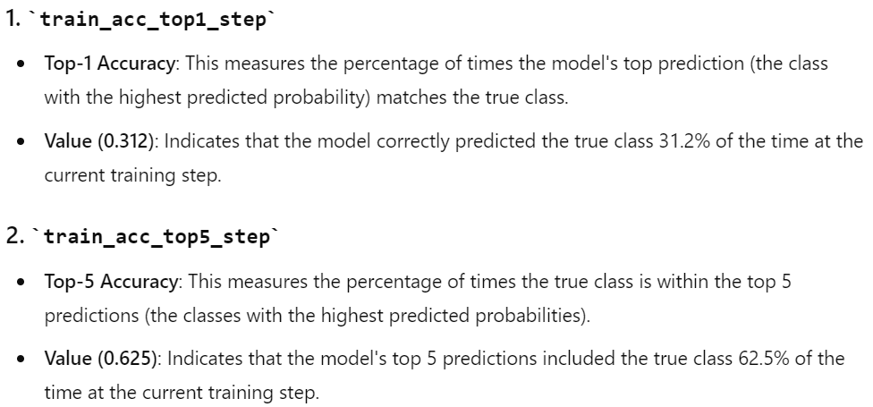

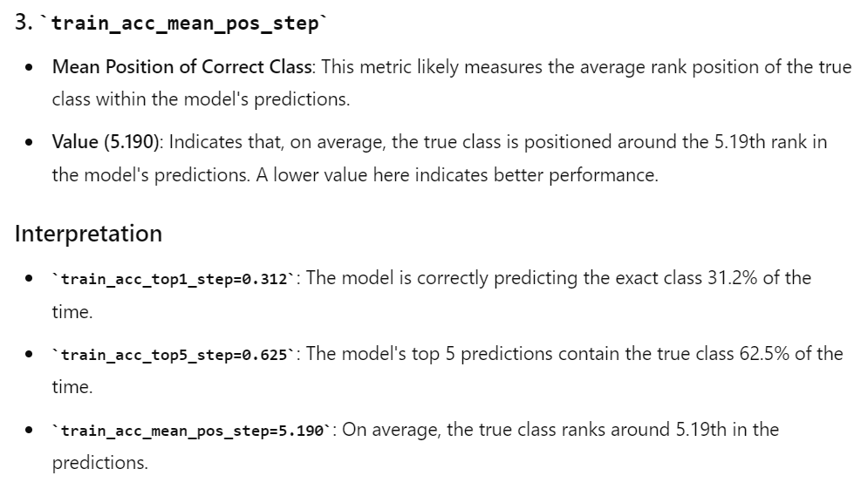

def info_nce_loss(self, batch, mode="train"):

data_a, class_a, data_b, class_b = batch

# class_a is always "vision" according to ImageBind

feats_a = [self.model({class_a[0]: data_a_i}) for data_a_i in data_a]

feats_a_tensor = torch.cat([list(dict_.values())[0] for dict_ in feats_a], dim=0)

# class_b could be any modality

feats_b = [self.model({class_b[idx]: data_b_i}) for idx, data_b_i in enumerate(data_b)]

feats_b_tensor = torch.cat([list(dict_.values())[0] for dict_ in feats_b], dim=0)

if self.hparams.self_contrast:

feats_a_b_tensor = torch.cat([feats_a_tensor.chunk(2)[0], feats_b_tensor], dim=0)

feats_tensors = [feats_a_tensor, feats_a_b_tensor]

temperatures = [1, self.hparams.temperature]

contrast = ["self", "cross"]

else:

feats_a_b_tensor = torch.cat([feats_a_tensor, feats_b_tensor], dim=0)

feats_tensors = [feats_a_b_tensor]

temperatures = [self.hparams.temperature]

contrast = ["cross"]

# Accumulate self-contrastive loss for image and its augmentation, and modailty with image

dual_nll = False

for feats_idx, feats_tensor in enumerate(feats_tensors):

# Calculate cosine similarity

cos_sim = F.cosine_similarity(feats_tensor[:, None, :], feats_tensor[None, :, :], dim=-1)

# Mask out cosine similarity to itself

self_mask = torch.eye(cos_sim.shape[0], dtype=torch.bool, device=cos_sim.device)

cos_sim.masked_fill_(self_mask, -9e15)

# Find positive example -> batch_size//2 away from the original example

pos_mask = self_mask.roll(shifts=cos_sim.shape[0] // 2, dims=0)

# InfoNCE loss

cos_sim = cos_sim / temperatures[feats_idx]

nll = -cos_sim[pos_mask] + torch.logsumexp(cos_sim, dim=-1)

nll = nll.mean()

if not dual_nll:

dual_nll = nll

else:

dual_nll += nll

dual_nll /= 2

# Logging loss

self.log(mode + "_loss_" + contrast[feats_idx], nll, prog_bar=True,

on_step=LOG_ON_STEP, on_epoch=LOG_ON_EPOCH, batch_size=self.hparams.batch_size)

# Get ranking position of positive example

comb_sim = torch.cat(

[cos_sim[pos_mask][:, None], cos_sim.masked_fill(pos_mask, -9e15)], # First position positive example

dim=-1,

)

sim_argsort = comb_sim.argsort(dim=-1, descending=True).argmin(dim=-1)

# Logging ranking metrics

self.log(mode + "_acc_top1", (sim_argsort == 0).float().mean(), prog_bar=True,

on_step=LOG_ON_STEP, on_epoch=LOG_ON_EPOCH, batch_size=self.hparams.batch_size)

self.log(mode + "_acc_top5", (sim_argsort < 5).float().mean(), prog_bar=True,

on_step=LOG_ON_STEP, on_epoch=LOG_ON_EPOCH, batch_size=self.hparams.batch_size)

self.log(mode + "_acc_mean_pos", 1 + sim_argsort.float().mean(), prog_bar=True,

on_step=LOG_ON_STEP, on_epoch=LOG_ON_EPOCH, batch_size=self.hparams.batch_size)

self.log(mode + "_loss", dual_nll, prog_bar=True,

on_step=LOG_ON_STEP, on_epoch=LOG_ON_EPOCH, batch_size=self.hparams.batch_size)

return dual_nll

